**APRIL 3, 2016**

**SECOND SUNDAY OF EASTER “C”**

**and DIVINE MERCY SUNDAY**

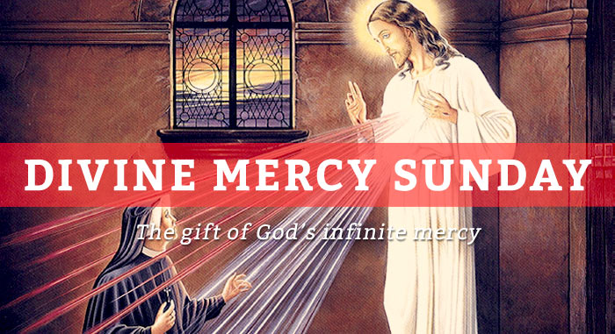

**Chaplain:**

Father Matthew Hysell, M.A., M.Th.

DeafCatholicEdmonton@CAEDM.ca

780-700-0234 text message only

In case of emergency, text to Father Matthew for assistance.

**Pastoral Worker**

Sister Elizabeth Kass, S.P.

780) 701-1817 *TTY*

780) 436-7255 *fax*

780) 446-7317 *text-message*

ekass@sistersofprovidence.ca *email*

**Chairperson**

Mr. John Shores

(780) 434-8640 *TTY*

John.Shores@ualberta.ca *email*

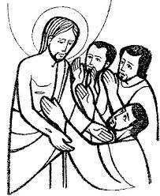

**When Thomas sees**

**Jesus he says**

**“My Lord and My God”**

**ICDA Canadian Section**

**Chapter # 108**

**Website:**

[**www.DeafCatholicEdmonton.org**](http://www.DeafCatholicEdmonton.org)

**Charitable Donation Number**

**11918-6757-RR0001**

**Today’s Readings**

**First Reading:** Acts 5:12-16

**Psalm** # 118

**Second Reading:** Revelation 1:9-11a, 12-13, 17-19

**Gospel**: John 20:19-31

**Next Sunday – April 10th – Second Sunday of Easter “C”**

**First Reading:** Acts 5:28-32, 40-41

**Psalm #** 30

**Second Reading:** Revelation 5:11-14

**Gospel:** John 21:1-19

**TODAY** is the Second Sunday of Easter and also Divine Mercy Sunday. This is also a Holy Year of Divine Mercy and God’s love and mercy towards us poor sinners is much greater than we can imagine. In today’s gospel, Jesus appears again to his Apostles and this time Thomas was with them. He had refused to believe that they had seen the Lord and now he says “My Lord and My God.” Jesus says we are more blessed to believe in him without seeing him.

MINUTE MEDITATION

The Gospel of Easter is very clear: we need to go back there, to see Jesus risen, and to become witnesses to his Resurrection.

*Pope Francis*

Do not abandon yourself to despair: We are the Easter people and hallelujah is our song.

*Saint John Paul II*

**Office and Mailing Address**

3005 - 119th Street • Edmonton, Alberta T6J 5R5 • (780) 436-7250